**WEEK 3**

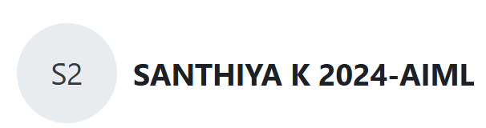

**Question 1:**

**Write a C program to find the eligibility of admission for a professional course based on the following criteria:**

**Marks in Maths >= 65**

**Marks in Physics >= 55**

**Marks in Chemistry >= 50**

**Or**

**Total in all three subjects >= 180**

**Program :**

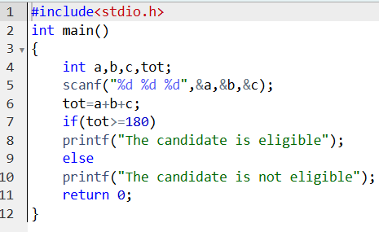

**Output :**

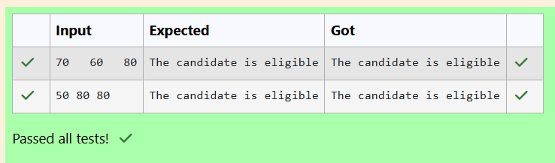

**Question 2:**

**Complete the calculator program with Basic operations (+, -, *, /, %) of two numbers using switch statement.**

**Program :**

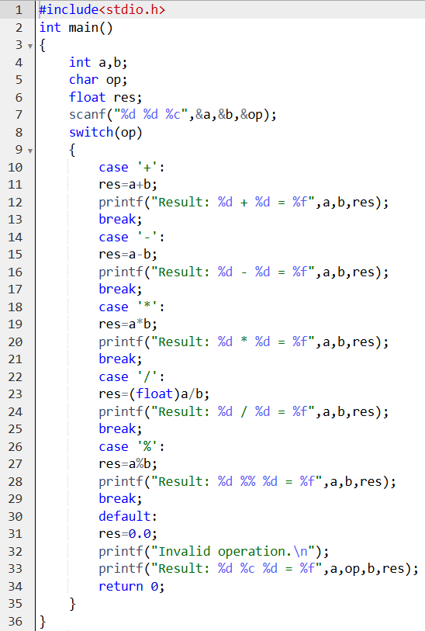

**Output :**

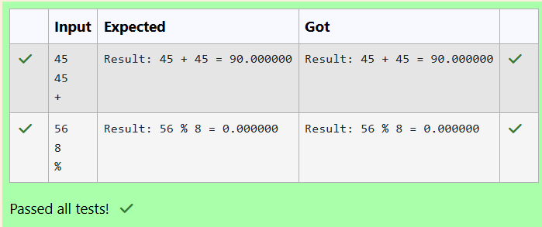

**Question 3:**

**You are given a sequence of integers as input, terminated by a -1. (That is, the input integers may be positive, negative or 0. A -1 in the input signals the end of the input.)**

**-1 is not considered as part of the input.**

**Find the second largest number in the input. You may not use arrays.**

**Program :**

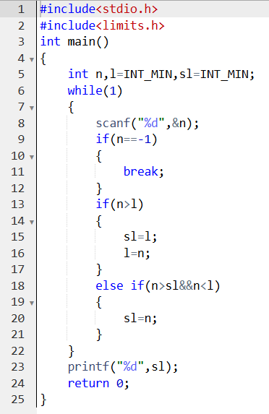

**Output :**

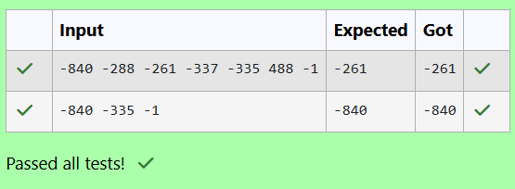

**Question 4:**

**The lengths of the sides of a triangle X, Y and Z are passed as the input. The program must print the smallest side as the output.**

**Program :**

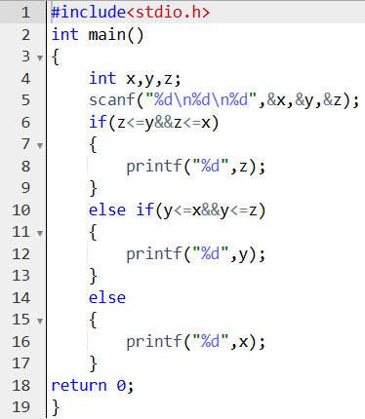

**Output :**

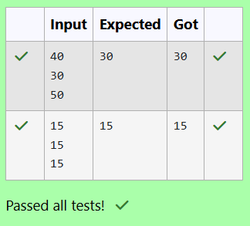

**Question 5:**

**See & retype the below code which will demonstrate about formal and actual arguments.**

**Program :**

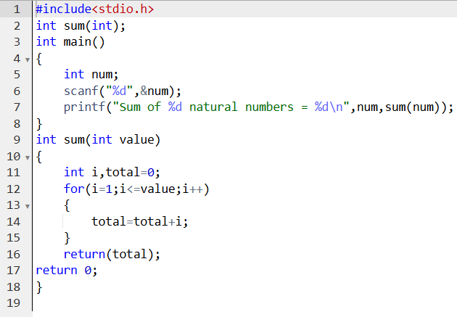

**Output :**

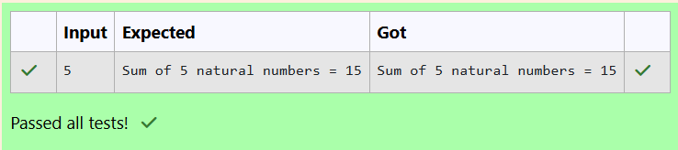

**Question 6:**

1. **See & retype the below code which will demonstrate about local variables**

**Program :**

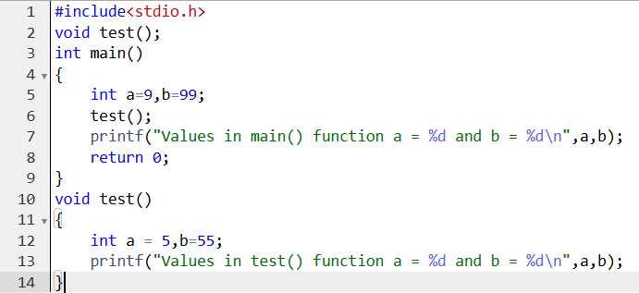

**Output :**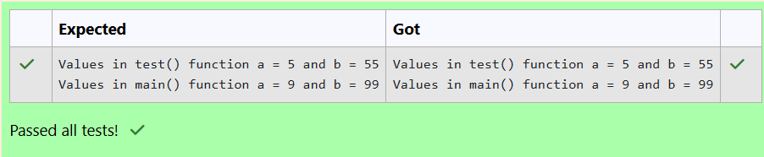

1. **See & retype the below code which will demonstrate about global variables.**

**Program :**

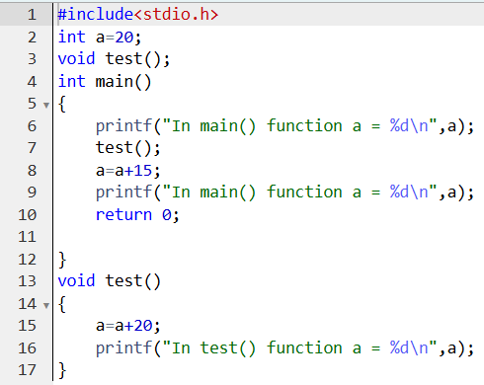

**Output :**

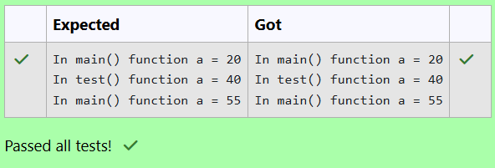

1. **See & retype the below code which will demonstrate about local and global variables.**

**Program :**

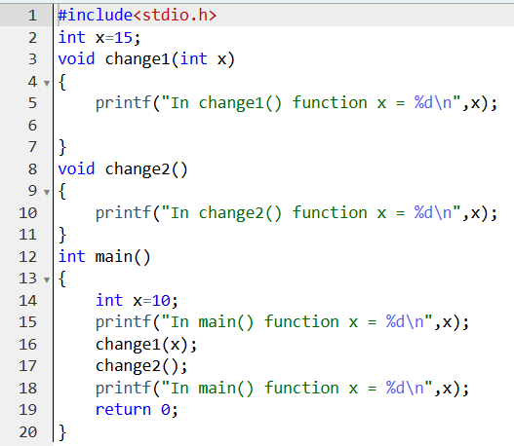

**Output :**

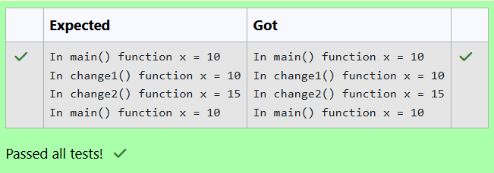

**Question 7:**

1. **Identify the below errors and correct them.**

**Program :**

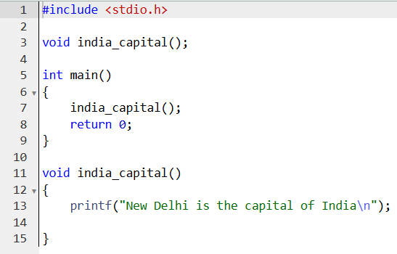

**Output :**

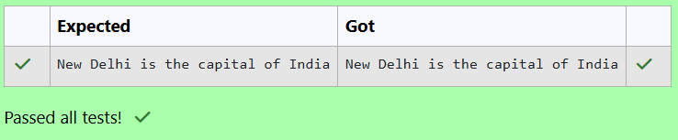

1. **Write a C program to demonstrate functions without arguments and without return value.Write the functions print() and hello().  
   The output is:**

**...***...**

**Hello! REC**

**...***...**

**Program :**

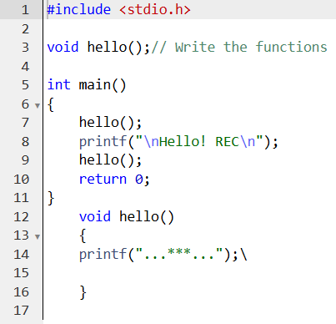

**Output :**

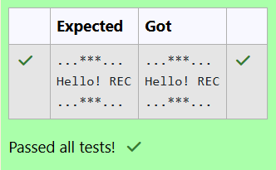

1. **Fill in the missing code in the below program to find the largest of two numbers using largest() function.**

**Program :**

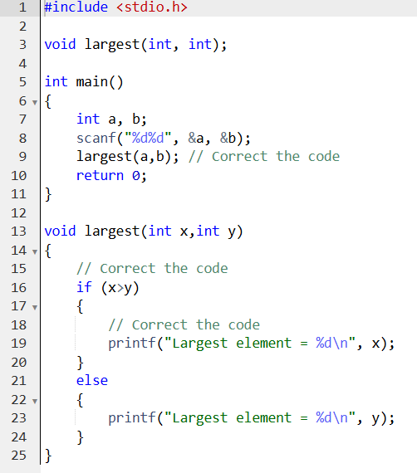

**Output :**

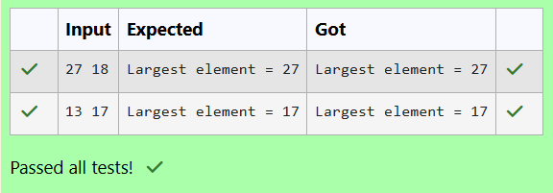

1. **Fill the missing code to understand the concept of a function with arguments and without return value. Note: Take pi value as 3.14.The below code is to find the area of circle using functions.**

**Program :**

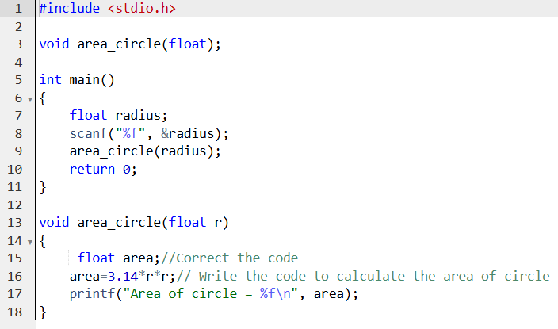

**Output :**

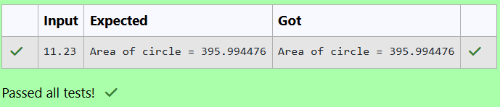

1. **Fill in the missing code in the below program to find sum of two integers.**

**Program :**

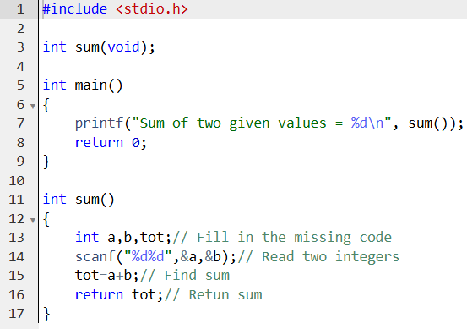

**Output :**

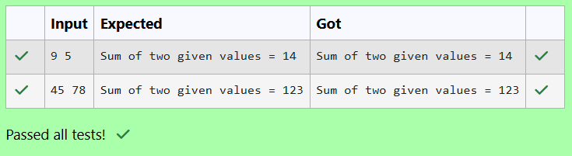

1. **Fill in the missing code in the below program to find the largest of three numbers using largest() function.**

**Program :**

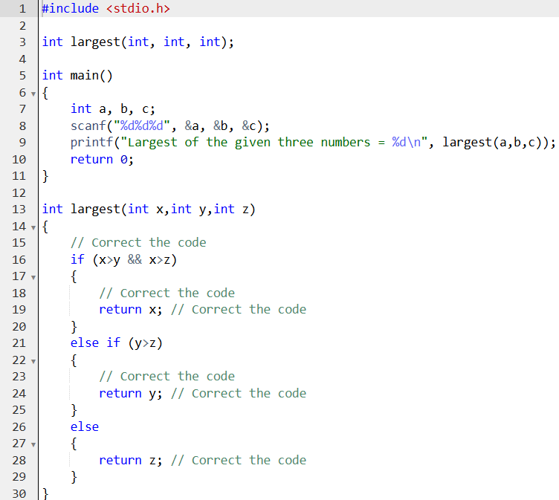

**Output :**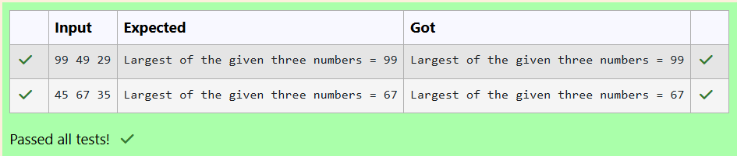

1. **Fill in the missing code in the below code to understand about function with arguments and with return value. The below code is to find the factorial of a given number using functions.**

**Program :**

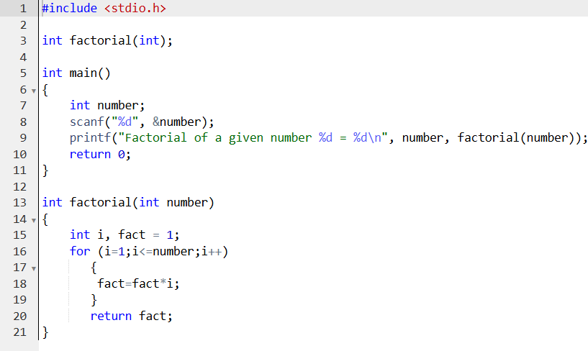

**Output :**

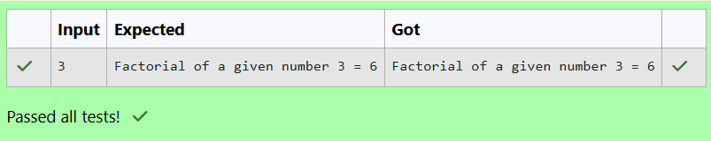

1. **Write a C program to demonstrate functions without arguments and with return value.The below code is used to check whether the given**

**number is a prime number or not.Write the function prime().**

**Program :**

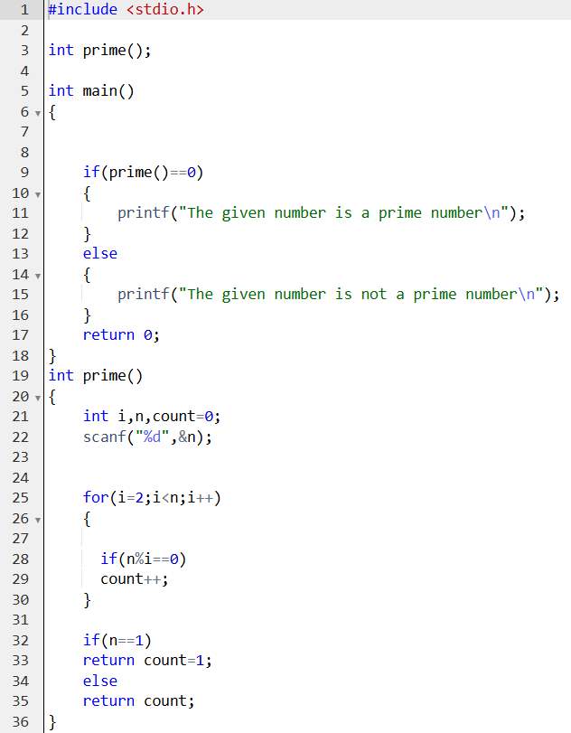

**Output :**

